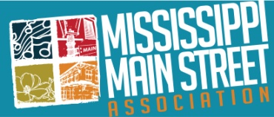
MISSISSIPPI MAIN STREET ASSOCIATION

2016 DOWNTOWN REVITALIZATION AWARDS
ENTRY DEADLINE – FRIDAY, APRIL 29, 2016 at NOON

The MMSA Downtown Revitalization Awards Program recognizes excellence in the field of downtown revitalization in Mississippi. There is no fee required to submit an entry. The 2016 Awards will be presented at the MMSA Annual Meeting and Awards Luncheon on Thursday, June 16 at the Old Capitol Inn in Jackson.

JUDGING
The jury will consist of a panel of downtown revitalization professionals, community and economic development professionals and historic preservation professionals, actively engaged in the field. The jury has the authority to grant no awards or as many as they believe are deserved within the categories outlined. The awards program chairperson and individual jurors are ineligible to receive awards. The judges will select projects based on the criteria of what is relevant to Mississippi.

ELIGIBILITY
- The individual, organization or entity submitting the nomination requires current MMSA membership in good standing. Nominations will only be accepted from those communities for which MMSA monthly reports, dues and Memoranda of Agreement are current.
- All entries must concern a project, program or effort that has been successfully completed during the past two years, has reached a point where completion is assured, or is an ongoing effort with measured success.
- The project, program or effort represented by the entry must be located in Mississippi and be a member of the Mississippi Main Street Association.

NATIONAL MAIN STREET ACCREDITATION
In 2016, the nationally accredited Mississippi Main Street communities will be recognized during the awards meeting but the certificates will not be handed out; they will be mailed directly to the local Main Street office.

APPLICATION

- All award entries must be submitted on a flash drive or cd. NO paper entries will be accepted.
- Entry forms must be completed for each entry, and saved to the flash drive or cd. Multiple entries may be placed in separate named folders on a single flash drive.
- A maximum of 6 ENTRIES MAY BE SUBMITTED; ONLY ONE (1) EACH in the categories of Organization, Promotion, Design, and Economic Vitality. Additionally, no more than TWO (2) nominations may be made in the category of Special Awards.
- Each Nomination may contain NO MORE THAN TEN (10) documents:
File 1 – Nomination Entry Form - Word document (.doc or .docx), Do NOT send a pdf.
File 2 – Narrative page - Word document (.doc or .docx), (see criteria below) no more than
ONE (1) page, double-spaced, 11 point or larger Times New Roman font,
submitted as a .doc or .docx file. Do NOT send a pdf of this page. Submissions not in this format will be returned.
Files 3 through 10 – no more than 8 individual jpg images of 300 dpi or greater, each one
named with a descriptive title as the file name. Example: “File 3 Building exterior”
or “File 6 Holiday Parade.”

SUBMISSION CRITERIA
The Narrative shall be no more than ONE (1) page, double-spaced, 11 point or larger Times New Roman font, submitted as a .doc or .docx file, describing the significance and strengths of the entry and why the entry is deserving of an award. Only one page will be accepted. This narrative should also list and describe the roles and responsibilities of other individuals, organizations, consultants, or entities that were/are involved in the project or program.

Appropriate supporting documentation for each category should be submitted (no more than 8 documents per entry in addition to the Entry Form and Narration page):
- Organization Category – Submit jpg scans of articles, pamphlets, brochures, etc., which describe the purpose and accomplishments of the organization. Include basic data and statistics.
- Promotion Category – Submit good quality jpg images (300 dpi or greater) of advertisements, articles, pamphlets, brochures, newsletters and/or digital photos, which may illustrate more clearly what is being described and give an overall understanding of the event.
- Design Category – Digital photos of design projects are required, submitted in jpg format of 300 dpi or greater. Include before and after photographs of renovation projects.
- Economic Vitality Category – Financial and business information is needed to support and explain projects or programs that have had or are having an economic impact to a downtown.
- Special Awards: Submit a one-page or less narrative and supporting photos, including a close-up of the nominee.
All materials will become the property of MMSA and it is understood that MMSA may use the material in future presentations.

FAQs and TIPS for Award Nominations

- What is a jump or flash drive? Do I have to use one?
A jump drive (also called a flash drive, thumb drive, etc.) is a small electronic storage device for electronic files and documents. A flash drive is inexpensive and will hold your nomination data easily. You may put several nominations on one flash drive. Submission on a cd is also acceptable. Paper nominations are not accepted.

- May I hand write an application or submit paper entries? In a word, no.

- How can I find out if my membership in MMSA is current (dues, monthly reports and MOA)? Login to the report generator to see if your reports are up to date (http://www.msmainstreet.com/index.php/managers) and call the MMSA Office at 601.944.0113 to check on dues and MOA status.
- How many awards can my community apply for?
ONE (1) nomination may be submitted in each of the four (4) categories of Organization, Promotion, Design and Economic Vitality, and no more than two (2) nominations in Special Awards. That’s a total maximum of six (6) nominations that may be entered by one community or entity.
- How can I win?
Be brief but inclusive with your narrative. Ask another person to edit and proofread your narrative. Consider hiring a professional photographer for your event or project. Judges will be considering several nominations in each category and the best presentation of photos and facts will win.

- What does 300 dpi mean? How do I make my photos this size?
300 dpi means 300 dots per inch. Higher DPI produces clearer and more detailed images. Low quality images cannot be made larger or better, but large photo files can be cropped and enhanced through software systems such as PhotoShop, iPhoto and Pixenate.

- Whom do I call with questions?
You may call your MMSA District Director, or call the MMSA Office at 601.944.0113.
- May I find out why my entry did not win?
While the judges’ comments will remain anonymous, you may call your District Director or the MMSA Office at 601.944.0113 and ask for feedback so that your entry next year will be better.

- How do I know if the Historic Rehabilitation project I submitted meets the Secretary of Interior’s Standards for Rehabilitation?
Make sure the project was approved by the Mississippi Department of Archives and History. If it was not, consider entering the project in a different category other than Historic Rehabilitation.

AWARD CATEGORIES

ORGANIZATION
- Premier Partner– recognizes creative joint ventures between the Main Street organization and another local, community entity or entities (public or private). Ventures can be community events, programs or publications.

- Outstanding Creative Fundraising – This award is granted to the downtown organization that has displayed the most creativity and success in securing funds for its downtown program or specific project.

- Outstanding Marketing – This award recognizes excellence in overall marketing by a downtown organization through its integrated communications efforts, including traditional and digital marketing (may include newsletter or news column, email and/or print newsletter, advertising campaigns, social media channels, and other media platforms). The overall marketing strategy should show how it is targeted, measurable and interactive.

- Outstanding Community Education Campaign – This award recognizes excellence in a targeted campaign that educates the community about a stream-lined effort to raise awareness on a particular aspect of a Main Street program, i.e. Farmers Market, community pride, beautification, Main Street advocacy, economic development, historic preservation, etc.

PROMOTION
- Creative New Event Under 5,000 (population) - This award recognizes the downtown organization that has created a quality creative event, generating traffic for the downtown. The activity must be a downtown organization event and includes festivals or other kinds of special events.

- Creative New Event Over 5,000 (population) - This award recognizes the downtown organization that has created a quality creative event, generating traffic for the downtown. The activity must be a downtown organization event and includes festivals or other kinds of special events.

- Outstanding Retail Promotion – This award honors the downtown organization that has developed an effective retail promotion(s) in conjunction with downtown merchants. The activity could be a sales-related event, special retail advertising campaign or non-sales related event.

- Outstanding Image Promotion – This award recognizes the downtown organization or business that has developed an effective public relations piece or specific promotional campaign. Projects may include the creation of a logo, brochure, advertisement or image/branding promotion campaign or event that motivates the consumer and promotes community loyalty.

DESIGN
- Best Historic Rehabilitation Project – This award is granted to an individual or business that has completed an outstanding historic rehabilitation project that continues the use of the building. The project must be located in the downtown district and should include exterior rehabilitation work but could be both interior and exterior work (including building facades). Must meet Secretary of Interior Standards for Rehabilitation.

- Outstanding Public Improvement Project – This award is given to the municipality or Main Street program that has designed and implemented attractive and sympathetic improvements for its district. Improvements must be within the Main Street district. Streetscapes are included.

- Best Visual Merchandising – This award recognizes excellence in visual merchandising in a retail business in a Main Street district.

- Outstanding New Development Project – granted to an individual or business that has undertaken a new development project within a downtown district. The project should not only achieve financial success and quality design, but also have a positive, measurable impact on downtown revitalization, including job creation and/or business expansion.

ECONOMIC VITALITY
- Outstanding Business Retention/Recruitment Program – granted to the downtown organization that has created and implemented the best retention and/or business recruitment program for its downtown. Examples of retention strategies are financial incentive programs, educational programs, etc. Recruitment considerations are downtown building inventories, market analyses, recruitment packets and the actual process of recruiting new businesses.

- Outstanding Adaptive Reuse Project – This award is granted to the best adaptive reuse of a building that has outlived its former use, including conversions to housing and office space, multiple businesses, public meeting space, restaurants, cultural centers, etc.

- Outstanding Economic Impact Project - granted to an individual, business or municipality (or partnership of entities) that has undertaken a new development project within a downtown district. This project does not have to be “brick and mortar” but should improve quality of life and have a positive, measurable impact on downtown revitalization, including job creation and/or business expansion.

- Outstanding New Business – granted to a new business in a downtown district that contributes to excellence in downtown revitalization.

SPECIAL AWARDS

No more than two (2) nominations for Special Awards may be submitted. A short narrative (one page or less) and relevant supporting data will help the jury in evaluating the entry as well. A good quality jpg photo of the nominee is required.

- Outstanding Community Transformation Award – This is an overall award that goes to a Main Street program that has achieved a successful, preservation-based downtown revival. The Main Street program has accomplished major goals in downtown revitalization and has both qualitative and quantitative examples to show the measurable impact. A heavy emphasis should be placed on the human resources it took to accomplish the work.

- Main Street Trailblazer Award in memory of Paul Coggin - Due to the commitment, time and enthusiasm that Paul Coggin brought to the Mississippi Main Street Association, a special award was established in his honor, given to an outstanding local board member or volunteer who has been active in a downtown organization for at least the last two years, and who has contributed energy and dedication to downtown revitalization. Please include the nominee’s tenure in the program or board and the extent of his/her contribution. A jpeg photo image (300 dpi or greater) of the nominee is required.

- Main Street Hero - This award recognizes an outstanding community leader or public figure who has displayed an involved commitment to downtown and his or her Main Street program.

- Main Street Excellence in Design Award in memory of Sam Kaye - Sam was an architect and community leader who served Mississippi Main Street Association as a staff member and design consultant from 1994 until his passing in 2013. As a member of the Board of Advisors of the National Trust for Historic Preservation, Sam’s involvement in historic preservation was nationally known and recognized. The Sam Kaye Excellence in Design Award is given to the design professional(s) or firm that exhibits the spirit, compassion and talent of the man for whom the award is named.

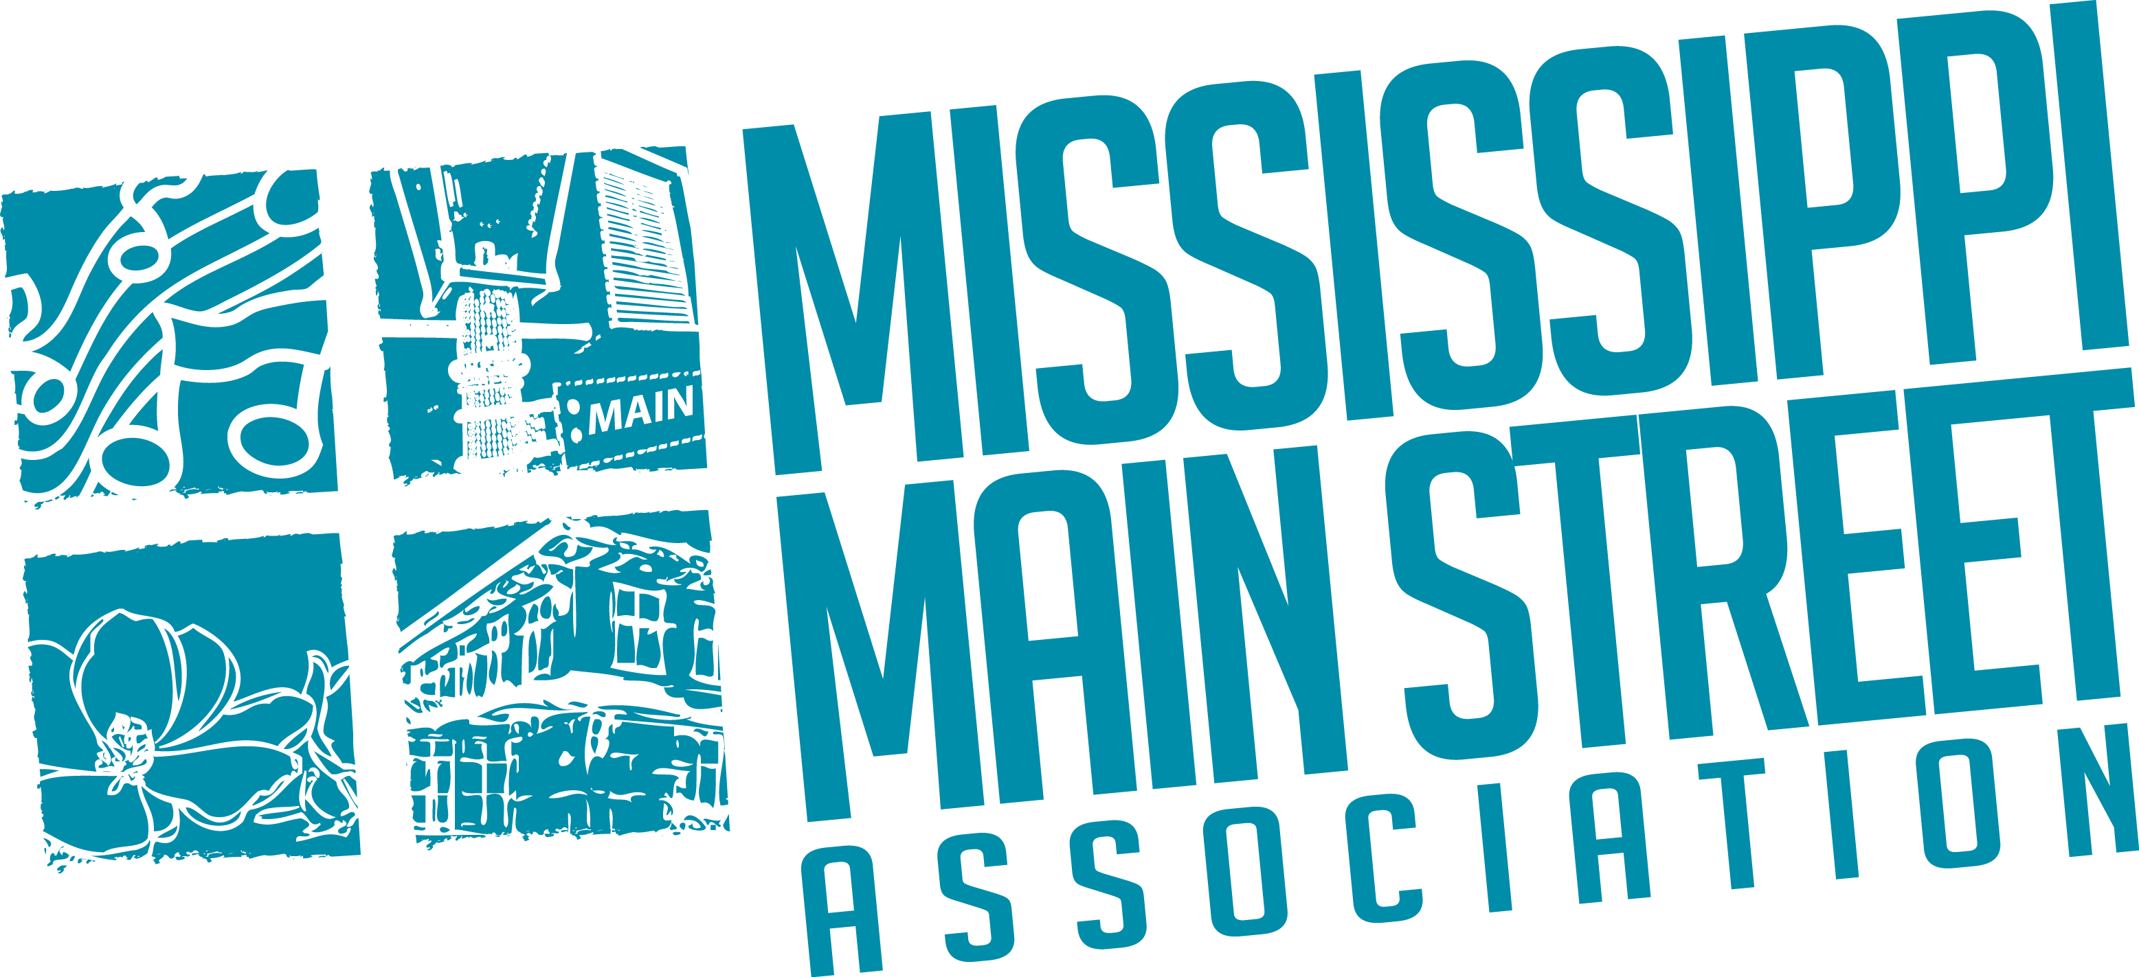

MISSISSIPPI MAIN STREET ASSOCIATION

2016

Award Nomination Form

- Name of Entry (Project or individual): _____________________________________

- Award Category (Check one): __ Organization
__ Promotion
__ Design
__ Economic Vitality
__ Special Awards

- Specific Award for which nominated: _____________________________________

- Short Description of the Entry: Limit to 150 words. Should your nomination receive the award, only this description will be used to describe the entry for the audience.

- Name of Submitter: _____________________________________
Organization: _____________________________________
Telephone: _____________________________________
Email address: _____________________________________
Mailing address: _____________________________________
_____________________________________

- Name the ONE individual who will accept the award at the luncheon, if chosen:
_____________________________________

Entries should be submitted on a flash drive to: Mississippi Main Street Association
P.O. Box 55747
Jackson, MS 39296

ALL ENTRIES MUST BE RECEIVED AT THE MMSA OFFICE IN JACKSON
BY NOON on Friday, April 29, 2016. ALL OTHERS WILL BE DEEMED INELIGIBLE.

